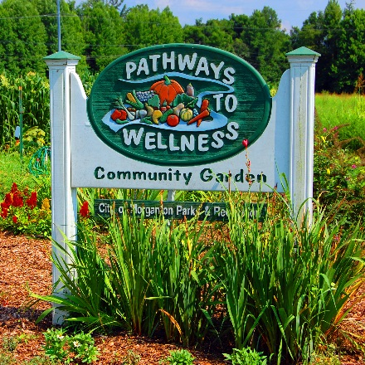
2022 Community
Garden Application

City of Morganton Parks & Recreation Dept.
Office: 828-438-5350
Mailing Address: P.O. Box 3448
Morganton, NC 28680

Morganton and Burke County Gardeners are encouraged to apply for a garden space/plot in the City of Morganton Parks and Recreation Department Community Garden located at 701 Sanford Dr. at Catawba Meadows Park. Gardeners must pay a $30.00 fee to use each plot. The fee covers some operations costs including water, straw, equipment, etc. Plots may be shared, which can be very helpful, because gardening is a lot of work including soil preparation, planting, sowing, tilling, weeding and harvesting. Only 2 plots per house hold.
Make checks payable to: City of Morganton

Plot rental dates: March 1, 2022 through November 30, 2022 (Make sure to remove all personal materials out of your plot)
NOTICE
PLEASE DO NOT DRINK THE WATER
DO NOT USE ANY PESTICIDES IN THE GARDEN
PLEASE CLEAN UP YOUR PLOT (STAKES, STRING, TOOLS, ETC) AT THE END OF THE SEASON (YOU WILL BE CHARGED A $30 FEE FOR CLEANUP).

Name: ________________________________________________________________

Home Phone: ______________________Cell Phone: _________________________

Address: ______________________________________________________________

Email: _________________________________________________________________

Date Paid: __________________________ Receipt Number: ________________

