Minutes

Morganton Planning & Zoning
January 11, 2024

Members Present: Members Absent:
Hank Dickens, Chairman Eric Engstrom
Pete Wallace, Vice Chairman
Judy Francis
Don Smith
Erin Kizer
Bill Lennon
Waits Gordon
Rick Lingerfelt

Also present from the City staff were Wendy Smith, Director Development & Design; Louis Vinay, City Attorney; Jackie Cain, Administrative manager

- OLD BUSINESS:

Item 1: Review and approval of minutes.

Mr. Dickens stated a minutes from the September 14, 2023 were provided for review. Minutes were approved as submitted. (8-0)

Item 2: Review of City Council action since last meeting
- Consideration for an application submitted by 400 Meeting Street LLC to rezone the property listed as 500 E Union Street (REID #31783), 501 E Meeting Street (REID 3890), 0 E Meeting Street (REID #2979), 503 E Meeting Street (REID 32978), 505 ½ E Meeting Street (REID #1414).. The property is currently zoned High Intensity District (HID) and the application is to re- zone to Central Business District (CBD)
- Consideration for an application submitted by Settlemyer Holdings, LLC to rezone the property listed as 770 Kirksey Dr (REID #45188) and 0 Kirksey Drive (REID 30395). The property is currently zoned Exclusive Intensity District Corridor Overlay (EID CO) and the application is to re-zone to High Intensity District Corridor Overlay (HID CO).

II. APPEARANCES:

Mr. Dickens stated this time is set-aside for individuals to come before the planning board to express any planning related concerns to the planning board.

None.

- NEW BUSINESS:

Item 1: Consideration for an application submitted by Brandon Dylan and McKenzie Enterprises LLC to rezone the property listed as 0 S Sterling Street (PIN # 2703806489). The property is currently zoned Medium Intensity District Corridor Overlay (MID-CO) and the application is to re-zone to High Intensity District Corridor Overlay (HID-CO).

Mr. Dickens asked for Ms. Smith to review this item.

Ms. Smith presented the rezoning application.

Case Number | 01-24
Date | January 11, 2024
Applicant | Tim Lail
Address (PIN#) | 0 South Sterling Street (2703806489)
Current Zone | Medium Intensity District (XXX) with Corridor Overlay (XX)
Proposed Zone | High Intensity District (XXX) with Corridor Overlay (XX)

Background
An application was submitted by Tim Lail, owner of Momentum Car Care at 1908 South Sterling Street, to rezone the adjacent 0.68 acre parcel at 0 South Sterling Street (2703806489) to the same zone as 1908 South Sterling Street to be developed with an extension of the existing motor vehicle services use on that property. Specifically, the business proposes to utilize the land at 0 South Sterling Street for extra parking for the motor vehicle services use.

The property is located on the corner of South Sterling Street and Moose Street as shown on Map 1– Location Map.

Map 1 – Location Map
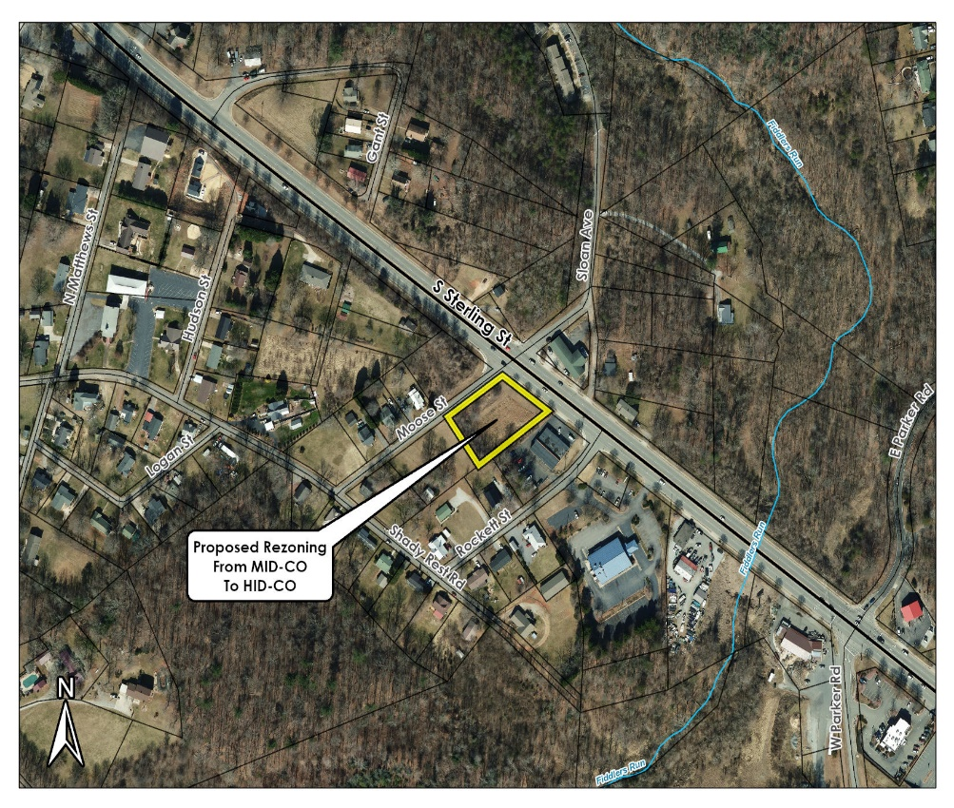
Current Zoning and Use - The property is currently zoned Medium Intensity District (MID) with all but an approximately 300sqft portion of the lot in the Corridor Overlay, as shown in Map 2 – Current Zoning. The lot is currently vacant and undeveloped, though recently it has been used for overflow parking for the motor vehicle services use located on the adjacent lot in Zone High Intensity District (HID).

Map 2 – Current Zoning
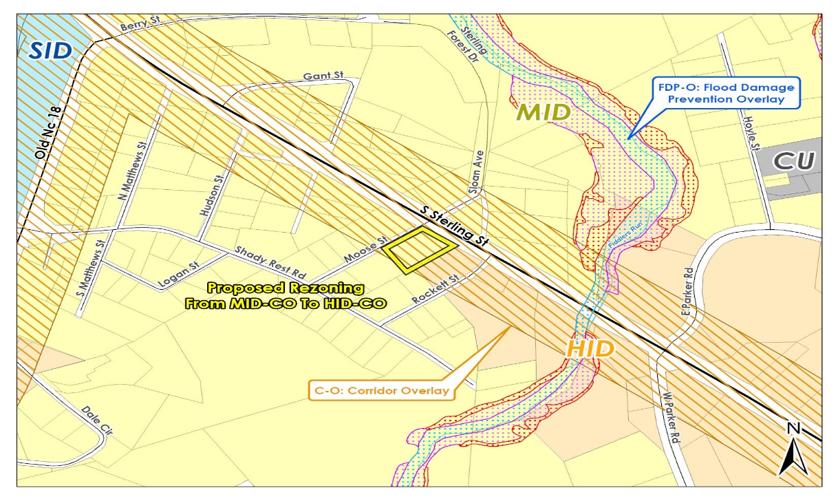

Surrounding Development – The parcel is bounded to the east by South Sterling Street, a major corridor entering Morganton from Interstate 40. The parcel is bounded to the north by Moose Street, which provides access to an older residential neighborhood with lots in both Zone Medium Intensity District and Zone Low Intensity District. Land across Moose Street from the subject site is located in Zone MID and is currently vacant, with a marked elevation change such that the property across the street is much higher than the subject site. Any new development on the parcel across the street would look down upon this site, rather than being overshadowed by the subject site.

The parcel to the west immediately adjacent the rear of the subject property is vacant except for a shed associated with a residential parcel located further down Moose Street. The parcel to the south is located in Zone High Intensity District and is developed with Momentum Car Care, a motor vehicle services business. While the motor vehicle services business has sufficient parking on the site for the business as required under the Zoning Ordinance, the success of the business is such that additional parking is needed to accommodate customer demand, which is the reason for the this rezoning request.

Access – There is existing access to the site off South Sterling Street, with an existing curb cut in this location. Access is proposed to be taken from this existing location. South Sterling Street is an NC Department of Transportation road and any future access arrangements would be subject to approval from that agency.

Water – The site has the potential to access the public water system, as shown in Map 3 – Utilities. If upgrades are required to service future developments, the upgrades will be at the developer’s expense.

Sewer – The site has the potential to access the public sewer system, as shown in Map 3 – Utilities. If upgrades are required to service future developments, the upgrades will be at the developer’s expense.

Map 3 - Utilities
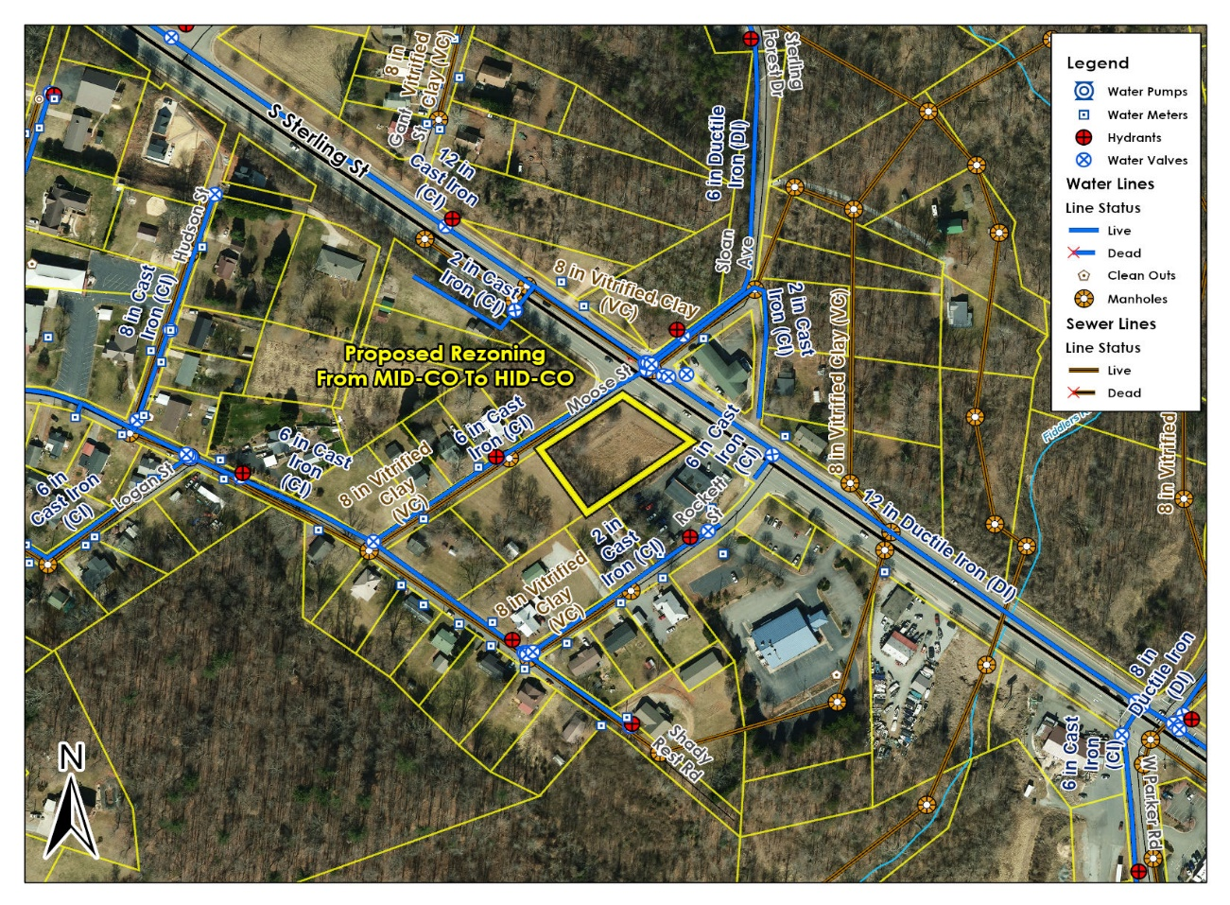

Proposal
The application is to rezone the site to High Intensity District (HID) with the Corridor Overlay.

The applicant is seeking to rezone the property for potential future development in line with the Mission 2030 Comprehensive Plan Future Land Use Map, as discussed further below.

Zone Comparison
The Medium Intensity District is intended for a variety of medium to high density residential and low to medium intensity civic, institutional, office, service, and retail uses designed to keep the impact on adjacent residential areas at a minimum.

The High Intensity District is established to accommodate high density residential and wide variety of civic, institutional, retail, service, and office uses along major arterials within the City and to ensure these uses are attractive, functional, and do not have a harmful effect on adjacent neighborhoods or other commercial areas of the City.

Overlay
The intent of the Corridor Overlay is to establish a minimum standard of development along the main thoroughfares within the City to enhance the appearance of Morganton and promote attractive and stable economic development. This overlay applies to any portion of the property within 250 feet of South Sterling Street.

No change is proposed to either Overlay District as part of this proposal.

The following table taken from Table 3.1 Permitted Uses of the Zoning Ordinance shows a comparison of permitted uses in the two zones, along with Overlay exceptions:

Table 1 – Permitted Uses Comparison
Agricultural Uses | Overlay Exceptions | MID | HID | Limitations
Bona fide farms (excluding swine production, see Section 1.4.2 for ETJ exemption) | Not permitted in NC-O, RR-O | P | P | 3.4.1 (C)
Equestrian uses (horseback riding, stables) |  | P | P | 3.4.1 (A)
Livestock and fowl keeping (accessory to residential use) |  | P | P | 3.4.1 (B)
Livestock and fowl keeping (principal use) | Not permitted in NC-O, RR-O |  |  | 3.4.1 (C)
Greenhouse or horticultural nursery (no retail sales) | Not permitted in NC-O, RR-O |  | P
Produce Stand (permanent) | Not permitted in NC-O, RR-O | P | P | 3.4.1 (D)
Residential Uses | Overlay Exceptions | MID | HID | Limitations
Accessory dwellings |  | P | P | 3.4.2 (A)
Accessory structures (residential) |  | P | P | 3.4.2 (B)
Bed & breakfast inns |  | P | P | 3.4.2 (C)
Boarding and rooming houses | Not permitted in NC-O | P | P
Family care homes |  | P | P | 3.4.2 (D)
Home occupations, customary (includes daycare homes) |  | P | P | 3.4.2 (E)
Home occupations, intensive | Not permitted in NC-O | P | P | 3.4.2 (F)
Manufactured homes on individual lots-see Section 3.2.2 | Only permitted in MH-O
Multi-family dwellings (includes apartments & townhomes) | Not permitted in NC-O | P | P | 3.4.2 (G)
Single-family dwellings (detached) |  | P | P
Two-family dwellings (duplexes) | Not permitted in NC-O | P | P
Civic, Government, & Institutional Uses | Overlay Exceptions | MID | HID | Limitations
Cemeteries | Not permitted in NC-O, RR-O | P | P | 3.4.3 (A)
Colleges, universities, & associated facilities |  |  | P
Community outreach offices | Not permitted in NC-O | P | P | 3.4.3 (A & B)
Correctional facilities | Not permitted in C-O, RD-O |  | P
Daycare centers, child and adult | Not permitted in NC-O | P | P | 3.4.3 (A)
Emergency services (fire, police, EMT, & similar uses) | Not permitted in NC-O | P | P | 3.4.3 (A)
Government office buildings | Not permitted in NC-O | P | P | 3.4.3 (A)
Hospitals, public and private |  |  | P
Libraries, museums, art galleries, & similar uses | Not permitted in NC-O, RR-O | P | P | 3.4.3 (A)
Post offices | Not permitted in NC-O, RR-O | P | P | 3.4.3 (A)
Religious institutions & related uses | Not permitted in NC-O, RR-O | P | P | 3.4.3 (A)
Research facilities | Not permitted in RR-O |  | P
Residential care facilities | Not permitted in NC-O | P | P | 3.4.3 (A)
Residential shelters | Not permitted in NC-O | P | P | 3.4.3 (A)
Schools, instructional (music, dance, martial arts, etc.) | Not permitted in NC-O | P | P | 3.4.3 (A)
Schools & associated facilities (public & private) | Not permitted in NC-O | P | P | 3.4.3 (A)
Schools (trade & vocational) | Not permitted in NC-O | P | P | 3.4.3 (A)
Social, fraternal, & philanthropic clubs & lodges, & similar uses operated on a non-profit basis | Not permitted in NC-O | P | P | 3.4.3 (A)
Office & Service Uses | Overlay Exceptions | MID | HID | Limitations
Animal services (no outdoor kennels) | Not permitted in NC-O | P | P | 3.4.4 (A)
Animal services (with outdoor kennels) | Not permitted in NC-O | P | P | 3.4.4 (A & B)
Artists, craftsmen | Not permitted in NC-O | P | P | 3.4.4 (A)
Banks, financial services | Not permitted in NC-O, RR-O | P | P | 3.4.4 (A)
Body art establishment (tattoos & body piercing) | Not permitted in C-O, RD-O, RR-O |  | P
Crematories |  |  | P | 3.4.4 (C)
Dry cleaning and laundry services (non-industrial) | Not permitted in NC-O, RR-O | P | P | 3.4.4 (A)
Funeral homes and mortuaries | Not permitted in NC-O, RR-O | P | P | 3.4.4 (A)
Hotels and motels | Not permitted in RR-O |  | P
Motion picture production | Not permitted in RR-O |  | P
Motor vehicle and boat services (with or without outdoor storage, includes gas stations and car washes) | Not permitted in RR-O |  | P | 3.4.8 (C)
Medical, dental, chiropractic, optical, psychiatric offices | Not permitted in NC-O, RR-O | P | P
Personal service uses | Not permitted in NC-O, RR-O | P | P | 3.4.4 (A)
Professional offices | Not permitted in NC-O, RR-O | P | P | 3.4.4 (A)
Services, other (no outdoor storage) | Not permitted in NC-O, RR-O | P | P | 3.4.4 (A)
Services, other (with outdoor storage) | Not permitted in RR-O |  | P | 3.4.8 (C)
Retail & Wholesale Uses | Overlay Exceptions | MID | HID | Limitations
Auction Houses | Not permitted in RD-O, RR-O |  | P
Farmers’ markets | Not permitted in NC-O, RR-O | P | P | 3.4.5 (A)
Microbreweries and wineries (with on-site sales) | Not permitted in NC-O, RR-O | P | P | 3.4.5 (A & B)
Motor vehicle or boat sales or rental | Not permitted in RR-O |  | P | 3.4.5 (C)
Mobile Food Vendors |  | P | P | 3.4.8 (D)(8)
Pawn shops | Not permitted in C-O, NC-O or RD-O, RR-O | P | P
Restaurants (no drive-through) | Not permitted in NC-O, RR-O | P | P | 3.4.5 (A)  3.4.8 (A & C)
Restaurants (with drive-through) | Not permitted in NC-O, RR-O | P | P | 3.4.5 (A)  3.4.8 (A & C)
Retail uses (less than 3,000 square feet, inside fully enclosed building) | Not permitted in NC-O, RR-O | P | P | 3.4.5 (A)
Retail uses (3,000 square feet or greater, inside fully enclosed building) | Not permitted in RR-O |  | P
Retail uses (outside fully enclosed building) | Not permitted in RR-O |  | P | 3.4.5 (D)
Wholesale (inside fully enclosed building | Not permitted in RR-O |  | P
Wholesale (outside fully enclosed building) | Not permitted in RR-O |  |  | 3.4.5 (D)
Recreation & Entertainment Uses | Overlay Exceptions | MID | HID | Limitations
Adult oriented businesses | Not permitted in C-O, RD-O, RR-O |  | P | 3.4.6 (B)
Auditorium, assembly hall | Not permitted in NC-O | P | P | 3.4.6 (A)
Banquet, events facility | Not permitted in NC-O | P | P | 3.4.6 (A)
Campgrounds | Not permitted in NC-O, C-O, RR-O | P | P | 3.4.6 (A & C)
Electronic gaming operations | Not permitted in C-O, NC-O, RD-O, RR-O |  | P | 3.4.6 (G)
Golf, tennis, swimming clubs & related uses  (private, not in a development) | Not permitted in NC-O | P | P | 3.4.6 (A)
Golf, tennis, swimming facilities, athletic fields & related uses (public) | Not permitted in NC-O | P | P | 3.4.6 (A)
Motorsports competition and testing facilities | Not permitted in RR-O |  | P | 3.4.6 (D)
Night clubs, bars | Not permitted in RR-O |  | P
Parks (public) |  | P | P
Private clubs | Not permitted in RR-O |  | P
Recreation facilities associated with a residential development |  | P | P
Recreation facilities (indoor, private) |  |  | P
Recreation facilities (indoor, public) | Not permitted in NC-O | P | P | 3.4.6 (A)
Recreation facilities (outdoor, private-including golf driving ranges, miniature golf, skateboard parks, water slides, batting cages, go cart tracks, & similar uses) | Not permitted in C-O |  | P | 3.4.6 (E)
Shooting ranges (indoor) | Not permitted in RR-O |  | P
Shooting ranges (outdoor-in association with local government only) | Not permitted in RR-O |  |  | 3.4.6 (F)
Theater (drive-in) | Not permitted in RR-O |  | P
Theater (indoor) | Not permitted in NC-O, RR-O | P | P | 3.4.6 (A)
Theater (open-air) | Not permitted in NC-O, RR-O | P | P | 3.4.6 (A & E)
Banquet and Events-Accessory Use |  | P | P | 3.4.6 (H)
Industrial, Transportation, & Utility Uses | Overlay Exceptions | MID | HID | Limitations
Airports and heliports | Not permitted in C-O, RD-O, RR-O |  | P | 3.4.7 (B)
Asphalt plants, mixing plants, concrete and asphalt | Not permitted in C-O, RD-O, RR-O |  |  | 3.4.7 (C)
Automobile parking lots or garages (principal use) | Not permitted in NC-O | P | P | 3.4.7 (A)
Bus and train stations | Not permitted in NC-O, RR-O | P | P | 3.4.7 (A)
Data centers | Not permitted in RR-O |  | P | 3.4.7 (D)
Distribution centers | Not permitted in RR-O
Electric transmission lines & appurtenances |  | P | P
Electric substations |  | P | P
Junkyards, salvage yards, recycling operations and similar uses | Not permitted in C-O, RD-O, RR-O |  |  | 3.4.8 (C)
Landfill (construction, demolition, land clearing & inert debris) | Not permitted in RR-O
Landfill (sanitary) | Not permitted in RR-O
Manufacturing, processing, & assembly (inside fully enclosed building) | Not permitted in RR-O |  | P
Manufacturing, processing, & assembly (outside fully enclosed building) | Not permitted in C-O, RD-O, RR-O |  |  | 3.4.7 (E)
Mining & quarrying operations | Not permitted in RR-O
Natural gas distribution lines & related appurtenances | Not permitted in RR-O | P | P
Power generation/production facilities (not including wind and solar) | Not permitted in C-O, RD-O, RR-O |  | P
Power generation/production, solar (individual use) | Not permitted in RR-O | P | P | 3.4.7 (F)
Power generation/production, solar (solar farm) | Not permitted in C-O, RD-O |  |  | 3.4.7 (F)
Power generation/production, wind (individual use) | Not permitted in C-O, RD-O |  |  | 3.4.7 (G)
Power generation/production, wind (wind farm)
Rail terminals or yards | Not permitted in RR-O
Recycling centers (excluding recycling operations) |  |  | P
Sewage collection lines, lift stations, & appurtenances |  | P | P
Sewage treatment plants (non-government, public) | Not permitted in C-O, RR-O
Taxicab services | Not permitted in RR-O |  | P
Telecommunication lines & related appurtenances | Not permitted in RR-O | P | P
Telecommunications towers (may require Board of Adjustment approval-see Section 3.4.7 (H)) | Not permitted in NC-O,  C-O, or RD-O, RR-O | P | P | 3.4.7 (H)
Transit stops |  | P | P | 3.4.7 (A)
Truck stops | Not permitted in C-O, RD-O, RR-O |  | P | 3.4.7 (I)
Warehouse uses (excluding mini-warehouses) | Not permitted in RR-O |  | P
Warehouse, mini | Not permitted in C-O, RD-O, RR-O |  | P
Water distribution lines, pumps, storage, tanks, & appurtenances |  | P | P
Water treatment plants (public) | Not permitted in RR-O
Other Uses | Overlay Exceptions | MID | HID | Limitations
Accessory structures (associated with permitted non-residential uses) |  | P | P | 3.4.8 (A)
Business kiosks (ATMs, movies, ice vending, etc.) | Not permitted in NC-O | P | P | 3.4.8 (A & B)
Drive-through/drive-in uses (associated with permitted use) | Not permitted in NC-O | P | P
Outdoor storage (associated with a permitted use, excluding outdoor sales display) | Not permitted in C-O, RD-O |  | P | 3.4.8 (C)
Temporary uses |  | P | P | 3.4.8 (D)

Additionally, the following tables taken from Table 4.2 Base Residential Density and Dimensional Standards, Table 4.3 Performance Residential Density and Dimensional Standards, and Table 4.4 Non-Residential Density and Dimensional Standards of the Zoning Ordinance provides a comparison of the dimensional and density standards (both base and performance standards) for each of the zones.

Table 2 – Comparison of Base Residential Density and Dimensional Standards:
District | Base  Max.  Residential  Density | Residential  Min. Lot Size  (Square feet)¹ | Min. Lot Width  (feet) | Front  Setback  (feet) | Side  Setback  (feet) | Rear  Setback  (feet) | Max.  Height (feet)
MID | 2 DUA | 20,000 | 70 | 20 | 10 | 20 | 35
HID | 6 DUA | 6,000 | 60 | 20 | 10 | 20 | 35
DUA=Dwelling Units per Acre
¹ The minimum lot size for infill development of less than two (2) acres shall be equal to the average of all lots within 200 feet of the property.

Table 3 – Comparison of Performance Residential Density and Dimensional Standards:
District | Performance Max. Residential Density¹ | Residential  Min. Lot Width  (feet)² | Front  Setback  (feet) | Side  Setback  (feet) | Rear  Setback  (feet) | Max.  Height (feet)
MID | 10 DUA | 50-detached  25-attached | 20  10³ | 5-detached  0-attached | 15⁴ | 50
HID | 20 DUA | 40-detached  25-attached | 20  10³ | 5-detached  0-attached | 5⁴ | 11-17 points =50  18 points and up =65
DUA=Dwelling Units per Acre
¹ There is no minimum lot size for residential developments utilizing the performance standards of Section 4.3. All districts shall be density-based.
² Detached lot widths apply to detached dwelling units, and attached lot widths apply to attached dwelling units. Any lots of less than 50 feet in width shall be alley-loaded and shall not have driveways accessing the fronting street.
³ Multi- family dwellings type 2
⁴ Garage doors for multi-family dwellings type 2 shall be set back a minimum of 18 feet
⁵ Residential Performance Standards do not apply in EID.

Table 4 – Comparison of Non-Residential Density and Dimensional Standards:
District | Min. Lot Size  (Square feet) | Min. Lot Width  (feet) | Front  Setback  (feet) | Side  Setback  (feet) | Rear  Setback  (feet) | Max.  Height (feet)
MID | 20,000 | 80 | 20 | 10 | 20 | 35
HID | 10,000 | 60 | 20 | 10 | 20 | 35¹
¹= See Exception Section 4.2.5 (F)

Rezoning the site to HID could allow any of the uses listed under HID in the table of uses above, as well as the setback and height allowances under the base standards for HID. Should a proposed development achieve appropriate performance standards, the HID performance standard density and dimensional standards would apply. The consideration should be whether those base, or performance, allowances are suitable for this site.

Comprehensive Plan Designation
The City’s Mission 2030 Comprehensive Plan’s Future Land Use Map, shown on Map 4 – 2030 Future Land Use indicates that the subject parcel’s future land use would be best suited as General Commercial/Retail. This General Commercial/Retail designation would typically involve a range of shop, office, restaurant, and other business uses, including motor vehicle services. The introduction of the current Zoning Ordinance in 2015 also introduced the ability to develop residential uses in all general commercial/retail zones.

The City is currently undergoing an update to the Mission 2030 Comprehensive Plan and taking a fresh look at the Future Land Use Map. The suitability of land uses throughout the City will be considered as part of this process. It is preliminarily expected that re-evaluation of the subject area will continue to support use of this site for general commercial/retail purposes.

Map 4 – 2030 Future Land Use
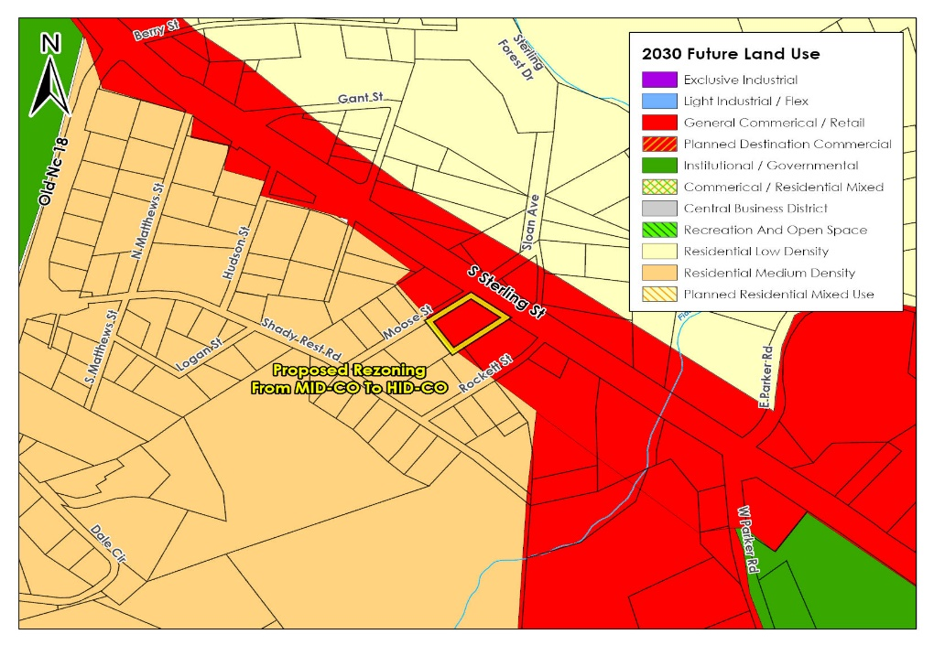
Assessment
The proposed rezoning is consistent with the Mission 2030 Comprehensive Plan Future Land Use Map and is in keeping with the expected uses for the locality, particularly in increasing the ability to utilize the site for commercial uses.

The proposal is in keeping with other commercial development along South Sterling Street in the locality and is keeping with the expectations of the Mission 2030 Comprehensive Land Use Plan for general commercial/retail uses.

The current proposal is for the motor vehicle services use on the adjacent parcel to be able to legally utilize the adjacent lot in similar ownership for vehicle parking associated with the existing successful business.

As the currently proposed use is for parking, no utility upgrades would currently be required; however, any utility or traffic impacts as a result of any future development of the site would be expected to be addressed by the developer at the time of development.

The inclusion of the Corridor Overlay with the current proposal is considered essential to any rezoning. The inclusion of the Corridor Overlay will ensure consistency of development with a pleasant presentation to the streetscape for passersby along the South Sterling Street road frontage.

Staff Recommendation
Staff recommends that the Planning and Zoning Commission approve this rezoning to High Intensity District with Corridor Overlay, as:
- creating a transition between zones across a street boundary, rather than in the middle of a block, provides more security for property owners of knowing what types of development may in future be constructed on adjacent lots and therefore reduces risks associated with development;
- the development of the site with general commercial uses is consistent with and fulfills the original expectation of the Mission 2030 Comprehensive Land Use Plan for the site;
- preserving the Corridor Overlay will ensure consistency of development with a pleasant presentation to the streetscape for passersby along the South Sterling Street frontage; and
- utility or traffic impacts from future development can be managed at the time of development.

The Planning and Zoning Commission recommend to the City Council support for the proposed rezoning of 0 South Sterling Street (2703806489), shown on the Mission 2030 Comprehensive Plan Future Land Use Map as General Commercial/Retail land from Zone Medium Intensity District with Corridor Overlay to Zone High Intensity District with Corridor Overlay, and the proposal is considered reasonable for the following reasons:
- creating a transition between zones across a street boundary, rather than in the middle of a block, provides more security for property owners of knowing what types of development may in future be constructed on adjacent lots and therefore reduces risks associated with development;
- the development of the site with general commercial uses is consistent with and fulfills the original expectation of the Mission 2030 Comprehensive Land Use Plan for the site;
- preserving the Corridor Overlay will ensure consistency of development with a pleasant presentation to the streetscape for passersby along the South Sterling Street frontage; and
- utility or traffic impacts from future development can be managed at the time of development.

Mr. Dickens asked commission if they had any questions for staff.

Mr. Dickens opened for public hearing.

No one was present to speak for or against the rezoning.

Mr. Dickens closed public hearing.

Ms. Francis wanted clarification of the current use?

Ms. Smith stated neither motor vehicle repairs or parking lots are allowed in the current zoning MID. Both uses are allowed in the proposed zoning HID.

Ms. Francis asked if buffer requirements were required for the neighboring residential use.

Ms. Smith stated there was a current buffer which meets the requirements and they plan on maintaining it.

Mr. Lingerfelt stated the Planning and Zoning Commission recommend to the City Council support for the proposed rezoning of 0 South Sterling Street (2703806489), shown on the Mission 2030 Comprehensive Plan Future Land Use Map as General Commercial/Retail land from Zone Medium Intensity District with Corridor Overlay to Zone High Intensity District with Corridor Overlay, and the proposal is considered reasonable for the following reasons:
- creating a transition between zones across a street boundary, rather than in the middle of a block, provides more security for property owners of knowing what types of development may in future be constructed on adjacent lots and therefore reduces risks associated with development;
- the development of the site with general commercial uses is consistent with and fulfills the original expectation of the Mission 2030 Comprehensive Land Use Plan for the site;
- preserving the Corridor Overlay will ensure consistency of development with a pleasant presentation to the streetscape for passersby along the South Sterling Street frontage; and
- utility or traffic impacts from future development can be managed at the time of development.

Seconded by Mr. Gordon and passed unanimously (8-0)

Mr. Dickens stated this would be presented to city council on February 5, 2024 at 6:00 pm.

Item 2: Consideration of zoning ordinance text amendments to limit residential
use on street frontage in Morganton Downtown National Historic District.
Mr. Dickens asked Ms. Smith to review the item. He stated this was one of ten items from the 2018 Downtown Vision Plan.

Ms. Smith stated staff requested to remove the item from the agenda out of abundance of caution in reviewing some of the advertisement requirements. She stated in order to meet all requirements of the ordinance.

Mr. Dickens asked Ms. Smith if we needed to open discussion of the item.

Ms. Smith stated she would like to discuss what the amendment was proposing since the item can be quite complicated when presenting text amendments. She stated she wanted to clarify what is being proposed.

Ms. Smith stated the proposal is to create new Active Frontage Overlay that will apply to street frontages with the Downtown Historic District only. Ms. Smith discussed the active ground floor frontages.
See map below:
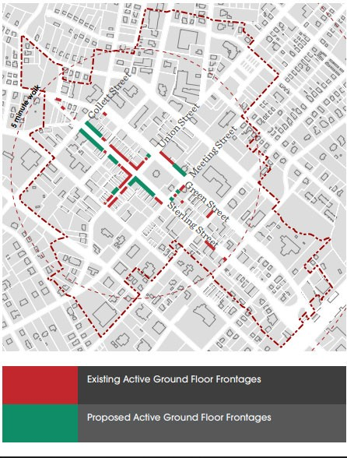
Ms. Smith stated this is only on ground floor street frontages, so any area which is not adjacent to the street front would not be affected. Ms. Smith clarified the area to be affected would be in the downtown Historic District only as indicated on the map shown on the screen and in the commission package (appendix D). Ms. Smith stated there are many recommendations from the 2018 Downtown Vision Plan, we are focusing on the residential use only. Ms. Smith stated as the inquiry for residential use in our downtown has increased. Staff has received some questions regarding the use of street front space as residential. She stated as a planning matter we want to encourage our local residents and tourist to walk downtown and shop, not to feel they are intruding on a personal residential space on the street front.
Ms. Smith stated planning did not want visitors to walk down the street and see the interactions of your tv playing and kitchen meal being prepared, but would like for window fronts to show clothing on a mannequin for sale, a wine shop or dine in restaurant. She explained this is why it applies to the street front, not the back alley’s where the public isn’t encouraged to be. She stated this does not affect upper levels of the downtown buildings.
She stated a door leading to an upper floor residence was allowed on the street front, this would not prohibit the access door.

Ms. Smith provided an example of accessibility. She stated if Swedes Café was converted to an apartment. You could not access the unit through Morganton General Store as you do Swedes. You would have a separate access door for the apartment. She stated this is independently occupied. She stated this ordinance change and overlay does not make any other changes to office use, retail use, civic, beauty shops, clothing stores etc.

Ms. Smith stated it does not make changes to existing uses downtown. Staff is not telling businesses or occupants they are going to have to leave. She stated anything of that sort is grandfathered in. She added that if there were questions regarding this information, that she would be available for additional explanation.

Mr. Dickens stated he wanted to clarify that the changes would apply to the Downtown Historic District area and not the entire Central Business District.

Ms. Smith stated correct. She stated that is the general 5 minimum walkable radius.

Mr. Wallace asked for clarification on the overlay district verse the Downtown Historic District.

Ms. Smith stated there is a new overlay district and the boundaries of the overlay district match those boundaries of the Downtown Historic District. She stated the Downtown Historic District is not a zone in the zoning ordinance it applies to historic preservation matters.

Mr. Wallace stated there was a typo listed as 3.2.1 and it appeared there was already a 3.2.1.

Ms. Smith stated yes, it should be 3.2.10 and typo was noted and would be corrected.

Mr. Dickens asked commission if there additional questions.

None.

Ms. Abby Nelson, former main street manager, stated she thought Ms. Smith did a great summation of what the request was seeking. She stated her statement is for the public hearing.

Mr. Smith questioned the 60% statement.

Ms. Smith stated that is not part of the proposal or Appendix D.

Mr. Dickens stated he felt this is maintaining the downtown frontage remain business use, it’s that simple.

Mr. Dickens made a motion to table action for consideration of zoning ordinance text amendments and zoning overlay to limit residential use on street frontage in Morganton Downtown National Historic District seconded by Mr. Wallace and passed unanimously (8-0).

Mr. Dickens stated this item would be on the Thursday February 8, 2024 planning & zoning agaenda.

OTHER ITEMS OF DISCUSSION

ADJOURN

Next Scheduled P&Z Meeting: Thursday February 8, 2023 at 5:15 PM
City Hall Council Chamber

